



PEAS: Practical Exemplars on the Analysis of Surveys

Report on User Evaluation of the PEAS web resource

Authors: Kathy Buckner, Gillian Raab, Susan Purdon, Iona Waterston

Date: 03 December 2004
Contents

Introduction
The main aim of the PEAS project is to develop a web-based resource that will provide the survey analyst with practical examples of the use of different methods for the analysis of complex surveys.
A prototype website was developed according to what are now recognised as fairly standardised web design principles (eg Levi & Conrad, 1996; Nielsen add reference) and in accordance with W3C’s Web Accessibility Initiative guidelines (http://www.w3.org/WAI/). Its development was an iterative process during which designs were evaluated by the project team, a prototype was developed and evaluated externally by a sample of potential users.

The aim of the external evaluation was to ensure that the resource met the needs and expectations of the users (Lazar, 2001 p2). Our objectives were to:

- Confirm, and gather further information about, the needs of participants in relation to survey analysis
- get user feedback on the accuracy and appropriateness of content
- evaluate the design and navigation of the website.

The evaluation of the PEAS web resource can best be described as being an iterative, formative process that took place during the design and development stage (Dix, 1993 p364; Draper et al 1996). The evaluation was formative rather than summative in that feedback from each phase of the evaluation was incorporated into subsequent iterations of the both the content and design.

User evaluation took place at three participatory workshops during the main period of resource development and remotely at the place of work of selected users during the later stages of development.

PEAS workshops
The workshops were integral to the development of the web resource. Their purpose was to:

- Further the overall aims of the project by spreading good practice in survey design and analysis both within and beyond the academic sector.
- Provide a forum for discussion and feedback about the contents and design of the website.
- To share experience and expertise in using survey analysis software between the developers and the participants. This was a two way process where we learnt from each other and also, in some cases, by working together in finding the best way to use the software and to understand what it was doing.

To fulfil the first of these aims participants were provided (through short seminar presentations) with information about specific aspects of survey design and analysis that related to the theory and exemplars being evaluated in the workshop. During the practical sessions participants were encouraged to extend their knowledge of survey analysis by exploring theoretical concepts, trying out the exemplars, and/or attempting to use software packages that were new to them.

The workshops were designed as collaborative codesign experiences (ref to codesign need to add in here – have I in fact described this at my third bullet poin??) in which the users, content developers and website designers were seen as equal partners. It was recognised that each participant group had something to learn from the others.

Timing and Venue
The workshops were held on 9 September, 22 October and 10 November 2004, at Comely Bank Campus, Napier University, Edinburgh. Workshops 1 and 3 were whole day events, whilst Workshop 2 was divided into morning and afternoon sessions with participants attending either the morning or afternoon sessions or in some cases? both sessions. A classroom was used for presentations and discussion (Figure 1) and a closed computer laboratory was available for the practical sessions (Figure 2).

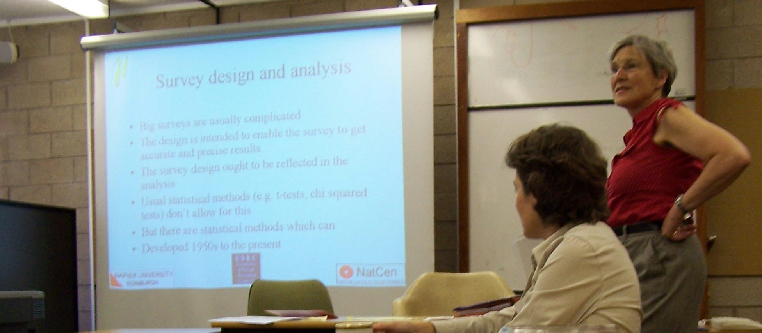
Figure 1: Workshop seminar presentation

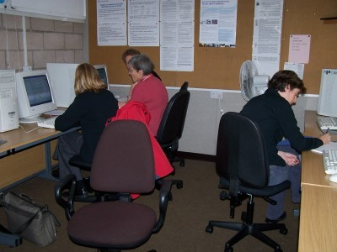
Figure 2. Practical exploration of PEAS

Participants
Participants were representative of the website’s target audience and were recruited from both the public and private sectors.

Participants for Workshops 1 and 2 were selected using the following criteria:
- researchers known to the organisers to have some expertise in survey methods and/or to have an interest in learning more about survey methods, or
- representatives from the organisations who are the major users of surveys featured in the exemplars (e.g.. Dept of Work and Pensions for the Family Resources Survey, Scottish Executive departments and University departments of public health for the Scottish Health and Household Surveys).

Workshop 3 participants were:
- people who met the selection criteria for Workshop 1 but who were unable to attend (3 only), or
- recruited via an announcement sent out via the ScotStat web site (http://www.scotland.gov.uk/stats/scotstats.asp) to individuals who had registered there as having an interest in using Scottish Official statistics data.

Overall, there were 13 representatives from governmental organisations, 5 from health and 11 from the educational sector (see Table 1).

 | Central Government | Local Government | NHS & MRC | Education (research & teaching) | Private | Total
Workshop 1 | 8 |  | 1 | 4 |  | 13
Workshop 2 | 2 |  | 1 | 3 | 1 | 7
Workshop 3 |  | 3 | 3 | 4 | 3 | 13
 | 10 | 3 | 5 | 11 | 4 | 33
Table 1: Workshop participants by sector

Each workshop was well balanced in terms of gender with the male:female ratios being 6:7; 3:4 and 6:7.

Each workshop was coordinated and lead by Gillian Raab, Principal Investigator on the PEAS project. Susan Purdon (Co-investigator - content) presented a seminar session on each occasion, whilst Kathy Buckner (Co-investigator – website design and evaluation) and Iona Waterston (Web Designer) coordinated the discussion sessions and collection and analysis of feedback questionnaires.

The workshop experience
The workshops were comprised of a mix of

- presentations on theoretical aspects of survey analysis (an example is provided in Appendix 2), and the others can be accessed on the final peas website (http://www.napier.ac.uk/depts/fhls/peas/workshops.asp)
- practical experience using the PEAS website in which participants undertook a range of tasks (see example task list in Appendix 3) in which they used the theory and tried out the exemplars using various software packages,
- providing feedback through individual and group discussion, feedback questionnaires and annotations to printed web pages.

Full details of the programme for workshop 1 can be seen in Appendix 4.

Participants were informed that it was the web resource that was being evaluated and not themselves. They were asked to be as open as possible in providing feedback to the developers.

Evaluation methods

Tasks
A series of representative tasks were derived to ensure that participants visited all the web pages that we wished them to evaluate (see example task list in Appendix 3). On each occasion there were a number of tasks available and these were allocated to participants or pairs of participants according to their prior experience or personal interest in exploring new techniques. For some tasks, requiring particular software packages, there were restrictions on the number of evaluators because of the limited availability of software licences. Each practical session lasted between one and one and a half hours.

Recording Feedback

in practical sessions
A number of alternative methods were considered. ‘Think aloud’ is a technique often used to attempt to ascertain what a person is thinking about as they use a website (Monk et al, 1993 p14). However a number of problems can arise using this method such increasing embarrassment of participants and affecting the way in which a system would normally be used. Because of these potential difficulties participants were encouraged to work on tasks in pairs. Participant observers (website designers and content developers) circulated to discuss technical and navigational issues as well as theoretical concepts and analytic practicalities. Working in pairs encourages talking between participants and in doing so they may reveal more about their concerns and perceptions than if they work on their own (Preece, 2000).

At all the workshops difficulties, confusions, and potential or realised problems were noted by the observers using pen and paper. At Workshops 1 and 2 participants were also asked to make notes about problems or issues that they wished to draw to our attention. It was observed however, that it was sometimes difficult, and time consuming, for participants and observers, to be specific about the precise place in the web resource where a problem had occurred. To resolve this difficulty printouts of relevant web pages were made and annotated with amendments and observations.

in group discussion sessions
Each workshop involved some group discussions. Topics included:
- Prior experience with complex surveys.
- Review of issues arising from practical sessions.
- Who is the web resource for?
- What do you need to know to get started?

Discussions were recorded either using pen and paper, or using audio recorders. Both methods were satisfactory as the nature of the evaluation did not require verbatim transcriptions of discussions. Indeed the room layouts were not particularly conducive for recording discussion and using this method did not significantly improve or ease the analysis.

by questionnaire
A structured, anonymous questionnaire (Appendix 5) containing open and closed questions was administered at the end of each workshop. The closed questions were designed to ascertain the attitudes of participants towards:

- presentation of information
- usability and navigation
- information coverage and level of content
- accuracy and authority
- potential for further use/development
- workshop tasks

The open questions provided participants with opportunities to comment more generally on their likes and dislikes and to provide additional feedback on how the resource might be further developed. The spaces for comment were used extensively and constructively.

Analysis of results
Observations and annotations from lab sessions related primarily to content and navigation. Missing links, error and omissions, suggestions for future development etc were noted by participants and observers. Immediately after each workshop these details were passed to the content provider. An annotated master copy of printed web pages was then produced for amendments to be made by the designer.

Recordings and notes from discussion sessions were transcribed by the Co-Investigator responsible for evaluation and quickly circulated to the rest of the team. Design issues were attended to by the designer and content issues by the content providers.

The questionnaire was completed by 85% (11/13) participants from Workshop 1; 57% (4/7) from Workshop 2 and 85% (11/13) from Workshop 3. Complete results of the closed questions are provided in Appendix 6.

Note that in the results section ‘participants’ refers to workshop attendees whilst ‘respondents’ refers to participants who completed questionnaires. Where response rate percentages are given these have been calculated as the percent of non-nul responses; numerical values are provided for clarity.

Results and discussion
The results of the evaluation workshops are presented and discussed in relation to the objectives for the user evaluation which can be summarised as:
- Confirm and gather further information about requirements of users.
- Accuracy and appropriateness of content
- Design and navigation of the PEAS website

User experience
Figures 3 and 4 show the range of prior usage of different statistical analysis software packages amongst Workshop 1 and Workshop 3 participants.

Figure 3: Prior experience: Workshop 1 Figure 4: Prior experience: Workshop 3

Figures 3 and 4 refer to use of the software packages, in general, rather than the use of their procedures for complex surveys. As previously mentioned participants in Workshop 1 were known to have some prior experience of survey analysis and were considered to be key informants in confirming our understanding of the potential requirements of users. This is reflected in the figures above which show a greater range of use of different software packages. Participants in workshop 3 were more likely to be only SPSS users, which (in our opinion) make them closer to what would be expected from most social researchers

Users had much less experience in using the specialist survey analysis modules from each of the packages. Table 2 summarises their reported responses on this topic. In fact this table over-represents their experience, at least of the Splu/R software, since it was established at the workshop that two of the three participants in workshop 3 who had reported using the R/Splus library had misunderstood the question. We did not check up formally on the other respondents, but the responses seemed to be in line with what we learned at the workshops.

It is hardly surprising that there is so little experience with using this software since it has only become available in the last two to three years.

Survey analysis | Workshop 1 | Workshop 3
Used SPSS complex surveys | 2 | 2
Used survey procedures in SAS | 4 | 0
Used of R or SPlus survey procedures | 1 | 3
Used survey commands in STATA | 1 | 2
Table 2:Prior experience with survey software

User requirements
Our initial discussions revealed that users have concerns about:
- why it is necessary to try to get analysis ‘right’: especially in organisations where it may be necessary to put in more resources to get it right eg time or money for additional software
- the scale of the problem: how big is the error/what is the impact if you don’t take account of complex designs in survey analysis and/or don’t undertake analysis correctly
- understanding when to use or more complex analytic technique
- finding out how to apply techniques properly.

This confirmed our prior understanding of user needs and helped us focus on determining appropriate approaches to support survey analysis.

Accuracy and appropriateness of content
Each group of workshop participants reported favourably on the level and amount of content, its relevance to them and how much they had learnt from using the PEAS resource. All respondents to the questionnaire found the website useful, and 92% (23/25) found the site relevant to them. Several participants thought that the resource would be particularly useful for training new researchers – either at a masters or doctoral level in higher education or during the early stages of a career in statistical analysis. Others felt that they would use the website as a reference resource. Overall, 92% (23/25) of questionnaire respondents thought the site would be a valuable resource for others and would send the URL to colleagues.

Almost all respondents thought that the information was trustworthy (96% 23/25) and accurate (92% 24/25). Even though the writing style was easy to comprehend (88% 22/25), 60% (15/25) felt that they did not understand all of the information presented. This is not a surprise as during our introductory discussions several participants had indicated that they felt there were gaps in their knowledge and experience.

Participants liked the way in which the exemplars had been used to demonstrate and apply theory. Several commented on the value of being able to see comparative results from the exemplars in a range of packages as most employers only provide one software package for analysis purposes. Interaction on the PEAS website is primarily facilitated through trying out exemplars. Detailed instructions are provided for this. Evidence from the questionnaire suggests that this type and amount of interaction is sufficient. Only 17% (4/24) wanted more interactivity.

Participants were complimentary about the clear explanations of theoretical concepts such as weighting, clustering, design effects etc. Where specific elements in the exemplars or theory were unclear workshop participants were extremely helpful in suggesting alternative approaches, techniques or detailed amendments to wording.

Most respondents 88% (22/25) felt a frequently asked questions (FAQ) section would be a useful addition to the site. This could be compiled from problems noted on discussion lists or from emails to the content providers. It would be useful to use web links to refer users from the FAQs to relevant theory sections and exemplars.

Using the PEAS website stimulated interest in survey analysis with 96% (24/25) of respondents wanting more information about analysis of survey data. However, only 2 people felt that they would be interested in contributing an exemplar to the site. This may be a reflection of individual confidence and current level of knowledge.

An alternative mode of stimulating further discussion about survey analysis has been provided through an online forum. With 56% (14/25) of respondents indicating that they would like to discuss issues with other people online this might become a viable self-help community.

Design and Navigation
All the questionnaire respondents found the website easy to use and liked the design. However there were some concerns that users did not always find navigating the site easy. In Workshop 3 60% (6/10) of respondents reporting that they had got lost when looking for information (Figure 5). This was concerning as most navigational anomalies had been fixed by Workshop 3 and ‘getting lost’ had not been a problem at all in Workshop 1 and only 2 people reported it to be a problem in Workshop 2.

It is possible that problems which were encountered with the server on which the website was hosted may have been a contributory factor. During the later part of the morning session in Workshop 3 the server ‘went down’ and users were unable to access some web pages. We quickly called a halt to the session and in the afternoon restarted by running PEAS locally from CD-ROMs. However, difficulties encountered in the morning may have influenced users’ perceptions of their ability to find information.
Figure 5: Getting lost when looking for information

The navigation difficulties of Workshop 3 participants may also be a reflection of prior experience in using survey analysis software (see discussion on prior experience above) as well as experience of using other web-based resources of this nature. We think this may be a contributory factor because three of the participants from Workshop 3 also reported difficulty in scrolling up/down to find other information – no other users reported any difficulty. The website is not intended to teach people how to use software packages In general, only the survey procedures. We have made this clear on the main software page of the site. Nevertheless, we appreciated at the workshops that some users would want to try to use some of the survey procedures from packages with which they had little familiarity so as to decide whether to invest further effort to learn them. To help such users we have supplied ‘getting started guides’ that will support users by teaching them the minimum knowledge they would need to run the exemplars (see example below).
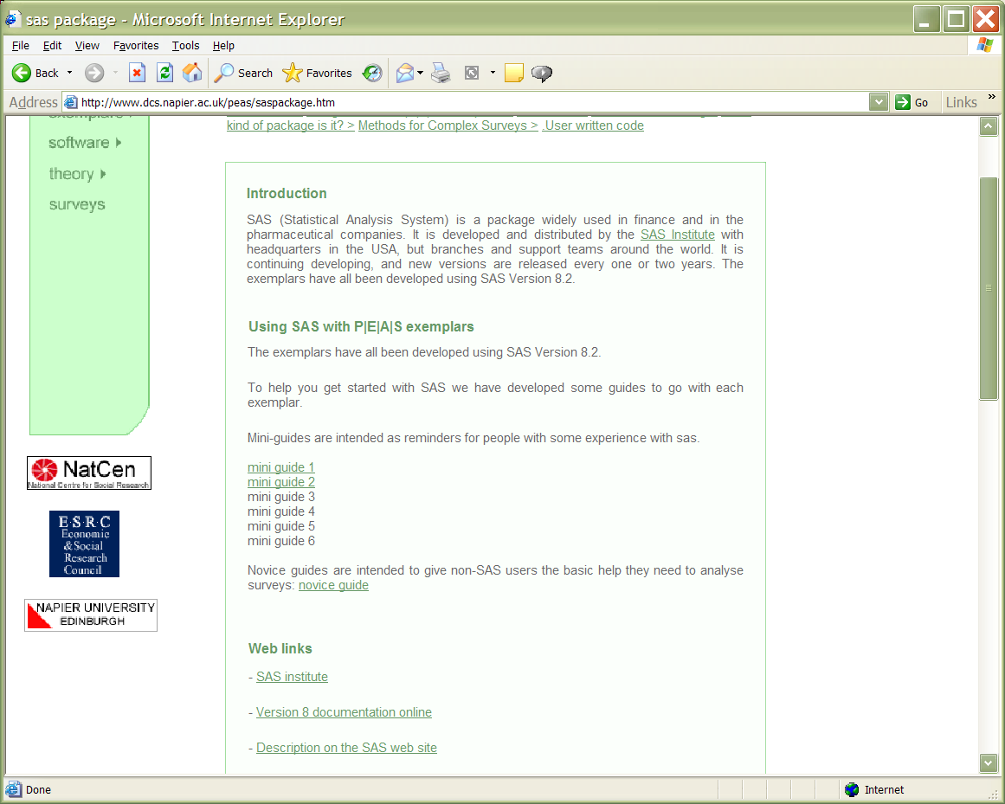

This issue and other observations also alerted us to the need to provide additional information about who the website is aimed at and how to get started. This was explored in more depth in a discussion session in the final workshop and, along with further debate between the designers and content providers, lead to the instructions shown in the screenshots below being developed .

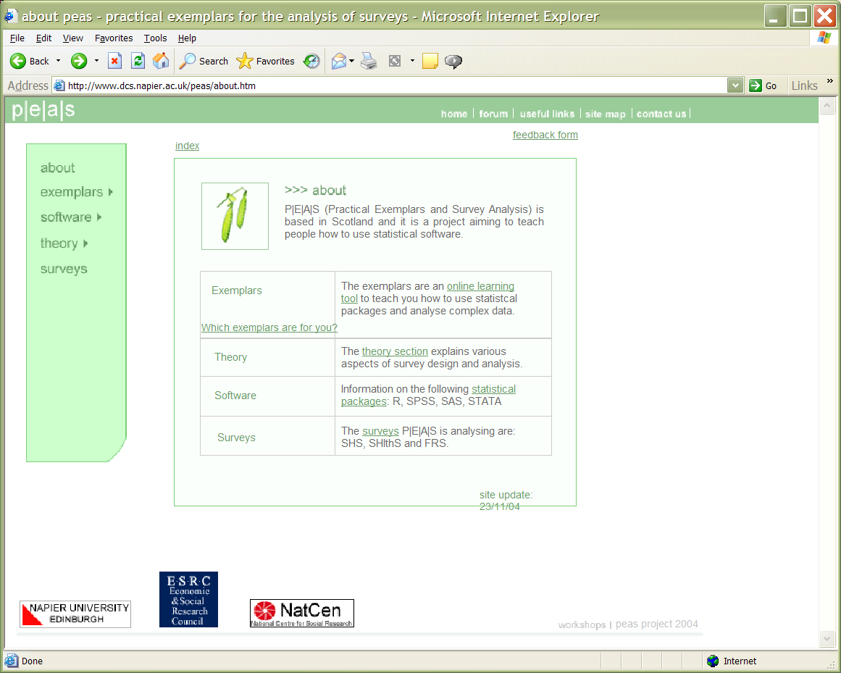
Figure xx: Modified introductory screenshot

Navigation was also improved by the inclusion of a site map containing an index of the main components of the site (see Appendix 7).

Graphics are used in the theory section and in the exemplars to illustrate specific contexts and/or to assist in technical explanations. All but one of the respondents from each of Workshops 1 and 2 felt that the graphics were relevant and aided understanding. Respondents from Workshop 3 were less uniform in opinion but nevertheless 67% (6/9) agreed with respondents from Workshops 1 and 2. Just over half of all respondents felt it would be beneficial to have more graphics on the web site. This is not an unanticipated view, however the developers (designers and content providers) feel that graphics should only be added where they aid understanding. Superfluous graphics can slow the download of web pages and any such delays have the potential to irritate and annoy users.

Before each workshop additional links (internal and external) were added, yet even by Workshop 3 40% (4/10) would still have liked to have had more links to further information. Part of this need appears to relate to a requirement for more explanation of statistical terminology (48% 12/25 overall; 80% 8/10 in Workshop 3). To resolve this a ‘mouseover’ glossary was developed. Terms that may be problematic are highlighted in the text and the definition appears in a pop-up box when the mouse is held over the term see screenshot below

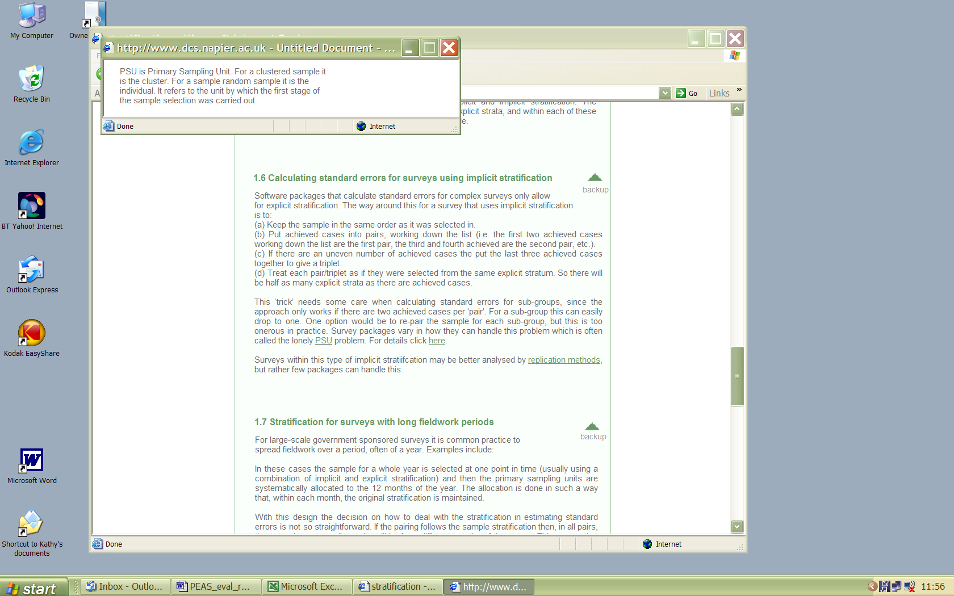
Here the abbreviation PSU is highlighted and when the user places his/her mouse over the text the box above opens with a definition o f the term.
PSU definition in pop-up box.
Figure xx: Pop-up glossary
This aspect was modified at the final stages of the project. The use of ‘alt’ text was reported to be problematic by some users because they did not show on all browsers. They also made it difficult to modify the content of the site since they had to be placed accurately on the page. Pop-up boxes were not entirely welcomed by users who commented on the site either, since they could pop up in an irritating manner when the mouse was placed over them by accident. A compromise that was welcomed by those who fed back on this aspect was to include a small information icon that showed where a popup box could be found and require the user to click on it before it appears. An example is shown in the screenshot below.

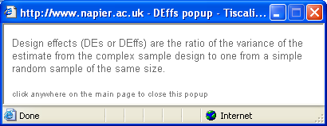
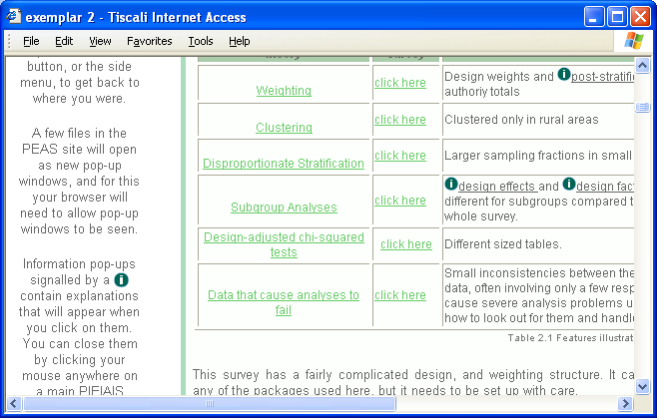

The workshops were particularly useful at identifying design issues, such as inconsistencies in numbering in theory sections, early in the development process. Problems such as these were addressed in subsequent iterations of the website.

Limitations
Initially we anticipated that holding a workshop every month in September, October and November 2005 would be sufficient to ensure that all main components of the website would be evaluated. However, because of the difficult nature of developing the exemplars it was not possible to evaluate all of the exemplars or all of the theory at the workshops. Exemplars 4, 5 and 6 and linked theory sections were therefore evaluated remotely by users working at their normal place of work and without direct observation of their use. Feedback was returned by email in January and feedback incorporated in this report. Where possible amendments have been incorporated into the website.

For some Workshop tasks requiring specific software packages there were limitations on the number of participants that could take part because of the availability of software licences.

Conclusions
Overall the website was well received by users and workshop participants reported that they had learnt a lot from using it. The resource was deemed to be a valuable resource for students undertaking projects in survey analysis, for new survey analysts starting out in their careers, and a useful reference source for more experienced researchers. It was noted that there are very few if any reference books that approach survey analysis from this perspective and thus the PEAS website appears to be filling a much needed gap.

To date we have not tested whether using the PEAS web resource has any significant impact on knowledge and understanding about survey analysis. To do this would involve establishing baseline knowledge, using a validated test instrument, in a sample of potential users of the site; providing these people with access to the resource for an appropriate period of time eg a month; and undertaking follow-up post-use testing. This work was not undertaken as it was outside the scope and resources allocated for this study.

Acknowledging the value of the resource raises the issue of its future maintenance and ongoing sustainability. Software packages are regularly upgraded with new versions, some disappear, new surveys are undertaken and others discontinued or modified, survey methods are developed, servers get old and are decommissioned. These are just some of the potential threats to the future viability and currency of the PEAS resource. The current grant does not make provision for maintenance and this is an issue that should be considered in the wider context of research methods information provision.

Appendices

Appendix 1 Participating Organisations by sector and location
 | Location
Education
Applied Psychology Department, Heriot Watt University | Edinburgh
Centre for Mathematics and Statistics, Napier University | Edinburgh
Centre for Research on Families and Relationships,  University of Edinburgh | Edinburgh
Child & Adolescent Health Research Unit | Edinburgh
Her Majesty’s Inspectors of Schools | Edinburgh
Public Health Sciences Section, Division of Community Health Sciences, Edinburgh University Medical School, | Edinburgh
Research Unit in Health, Behaviour and Change,  Edinburgh University Medical School | Edinburgh
School of Community Health, Napier University | Edinburgh
School of the Built Environment, Heriot Watt University | Edinburgh
Central Government
Environment Team, Scottish Executive | Edinburgh
Income and Poverty Statistics Branch | Edinburgh
Transport Statistics, Scottish Executive | Edinburgh
Department of Work & Pensions | London
Communities Scotland | Edinburgh
Local Government
Lanarkshire Council | Lanark
Policy and Organisational Development Service, Fife Council | Fife
Development and Regeneration Services, Glasgow City Council | Glasgow
Health
MRC Social and Public Health Sciences | Glasgow
Cancer Surveillance Team, NHS National Services Scotland | ?Edinburgh
Healthcare Information Group, NHS National Services Scotland | Edinburgh
ISD, NHS National Services Scotland | Edinburgh
Research and Evaluation, NHS Greater Glasgow Health Board | Glasgow
Private
Scottish Centre for Social Research | Edinburgh
National Centre for Social Research | London
Woodstock Centre | Kilmarnock

Appendix 2: Example seminar presentation (or one of Susans or all?)

Appendix 3: Example Task List
Evaluating PEAS web site 10th November 04

As we now getting towards the end of our development time and we are aiming to get the details of the site right and to clear up any bits that people find confusing.

In the morning we would like you to evaluate the ‘theory’ section of the site. But we would like you to look at the way in which the exemplars illustrate some of the points in the theory.

It would be especially helpful if you could suggest extra bits of explanation or links we could add. You will be working in pairs and each pair will have hard copies of the material on the site to use.

In the afternoon we will be asking you to try carry out and (if possible) extend the analyses that we have set up for you for each exemplar. You can decide which software package(s) you want to use for these, though we would like you to try some different ones. Each pair to take one exemplar.

Morning tasks
Pair no | Suggested tasks – but feel free to explore too | Hard copies
1 | What does stratification mean when it is applied to surveys?  In exemplar 1 what kind of stratification was used (implicit or explicit) and what is the difference between the two?  What effect did the stratification have on the standard errors estimated in exemplar 2? | Stratification  Exemplar 2
2 | How do survey organisations adjust for non-response?  What types of non-response adjustment were used in exemplar 3? | Non-response exemplar 3
3 | What does clustering mean when it is applied to surveys. What was the cluster used in exemplar 2?  What were the problems that arose with the data in exemplar 2 | Clustering  Exemplar 2  Data problems
4 | What is post-stratification? How was it used to adjust exemplar 1 to population totals?  What methods do you need to sue to analyse a subset of a survey?  What did the results from exemplar 1 show you about the effect of design features on subgroup estimates? | Non-response exemplar 1  Subgroups
5 | What is a design effect? What aspects of the survey made a difference to the design effect for exemplar 2? | Standard errors and design effects Exemplar 2
6 | Regression analysis and logistic regression for surveys. Which packages can do these? Does using weighting make a difference to any of the answers you get. You will need to look at some of the results files for this exemplar. | Exemplar 3  Main pages for packages.

Appendix 4: Example Workshop Plan
Practical Exemplars on the Analysis of Surveys
Workshop 9th September 2004
Napier University, Comely Bank Campus
Room F3/F12

Timetable

Time | Activity
9.30 - 9.45 | Arrival and coffee
9.45 - 10.15 | Presentation on PEAS survey - Gillian Raab
10.15 - 10.45 | Roundtable discussion
10.45 - 11.45 | Practical tasks explaining PEAS website
11.45 - 12.15 | Feedback session
12.15 - 14.00 | Lunch
14.00 - 14.45 | How survey design should affect analyses - Susan Purdon
14.45 - 15.00 | Introduction to tasks based on exemplars 1 and 2
15.00 - 16.00 | Practical data analysis tasks in computer lab
16.00 - 16.30 | Tea and feedback session

Appendix 5: Feedback Questionnaire

Practical Exemplars on the Analysis of Surveys
Workshop 10th November 2004
Web Interface Evaluation Form

Thank you for helping us to evaluate our web site. Please add any further comments at the end of the form
- In general, what did you think of the site?

- Is there anything you particularly liked?

- Is there anything you particularly disliked?

- Can you suggest what we could do to make the site easier to use?

Please answer the following questions. Your responses will be used in the evaluation of the website. Responses from individuals will not be made public but the collective results of the evaluation may be used in presentations or publications.

Please circle the most appropriate response.

presentation aspects
I found the website easy to use
  Strongly agree | Agree | Neither agree or disagree | Disagree | Strongly disagree
The text was too small to read easily
  Strongly agree | Agree | Neither agree or disagree | Disagree | Strongly disagree
The graphics took a long time to appear on screen
  Strongly agree | Agree | Neither agree or disagree | Disagree | Strongly disagree
The site was colourful
  Strongly agree | Agree | Neither agree or disagree | Disagree | Strongly disagree

Continue over page

navigation aspects
I got lost when looking for information
  Strongly agree | Agree | Neither agree or disagree | Disagree | Strongly disagree
It was easy to scroll up/down to find other information
  Strongly agree | Agree | Neither agree or disagree | Disagree | Strongly disagree
There were not enough links to allow me to find out other information
  Strongly agree | Agree | Neither agree or disagree | Disagree | Strongly disagree

presentation of information
The graphics were relevant
  Strongly agree | Agree | Neither agree or disagree | Disagree | Strongly disagree
The graphics added to my understanding
  Strongly agree | Agree | Neither agree or disagree | Disagree | Strongly disagree
I would like the site to have more graphics
  Strongly agree | Agree | Neither agree or disagree | Disagree | Strongly disagree
The writing style was easy to comprehend
  Strongly agree | Agree | Neither agree or disagree | Disagree | Strongly disagree
There was too much information on the site
  Strongly agree | Agree | Neither agree or disagree | Disagree | Strongly disagree
I don’t think I found all the information
  Strongly agree | Agree | Neither agree or disagree | Disagree | Strongly disagree
I would like the site to be more interactive
  Strongly agree | Agree | Neither agree or disagree | Disagree | Strongly disagree

relevance
I found the website useful
  Strongly agree | Agree | Neither agree or disagree | Disagree | Strongly disagree
I thought the website was relevant to me
  Strongly agree | Agree | Neither agree or disagree | Disagree | Strongly disagree

level of content
I didn’t understand all the information on the site
  Strongly agree | Agree | Neither agree or disagree | Disagree | Strongly disagree
I wanted more explanation about computer-related technical terms
  Strongly agree | Agree | Neither agree or disagree | Disagree | Strongly disagree
I wanted more explanation about statistical terms
  Strongly agree | Agree | Neither agree or disagree | Disagree | Strongly disagree
I would have liked some formulae in the theory section
  Strongly agree | Agree | Neither agree or disagree | Disagree | Strongly disagree

content
I think the information is trustworthy
  Strongly agree | Agree | Neither agree or disagree | Disagree | Strongly disagree
I think the information is accurate
  Strongly agree | Agree | Neither agree or disagree | Disagree | Strongly disagree

next steps
The site made me want more information about analysis of survey data.
  Strongly agree | Agree | Neither agree or disagree | Disagree | Strongly disagree
I would like to discuss analysis of survey data issues with other people on-line
  Strongly agree | Agree | Neither agree or disagree | Disagree | Strongly disagree
I would like to contribute an exemplar for inclusion in the site
  Strongly agree | Agree | Neither agree or disagree | Disagree | Strongly disagree
I would send the URL/ site address to a colleague
  Strongly agree | Agree | Neither agree or disagree | Disagree | Strongly disagree
It would be useful for the site to include a ‘frequently asked questions’ section
  Strongly agree | Agree | Neither agree or disagree | Disagree | Strongly disagree

Tasks assigned at workshop
I found the tasks in the morning session easy to complete
  Strongly agree | Agree | Neither agree or disagree | Disagree | Strongly disagree
I found the tasks in the afternoon session easy to complete
  Strongly agree | Agree | Neither agree or disagree | Disagree | Strongly disagree

Thank you for helping us to evaluate our web site.
Please add any further comments here

Appendix 6: Results of Workshop Questionnaires
 | Mean value | w/s no. | SA | A | N | D | SD | Nul | Total
 |  |  | 5 | 4 | 3 | 2 | 1
Presentational aspect
I found the website easy to use | 4.18 | w/s 1 | 2 | 9 | 0 | 0 | 0 | 0 | 11
 | 4.00 | w/s 2 | 0 | 4 | 0 | 0 | 0 | 0 | 4
 | 4.00 | w/s 3 | 0 | 10 | 0 | 0 | 0 | 0 | 10
The text was too small to read easily | 2.27 | w/s 1 | 0 | 1 | 3 | 5 | 2 | 0 | 11
 | 2.25 | w/s 2 | 0 | 0 | 1 | 3 | 0 | 0 | 4
 | 1.90 | w/s 3 | 0 | 0 | 1 | 7 | 2 | 0 | 10
The graphics took a long time to appear on screen | 1.82 | w/s 1 | 0 | 0 | 1 | 7 | 3 | 0 | 11
 | 2.00 | w/s 2 | 0 | 0 | 0 | 4 | 0 | 0 | 4
 | 2.33 | w/s 3 | 1 | 0 | 1 | 6 | 1 | 1 | 9
The site was colourful | 3.36 | w/s 1 | 0 | 4 | 7 | 0 | 0 | 0 | 11
 | 3.50 | w/s 2 | 0 | 2 | 2 | 0 | 0 | 0 | 4
 | 3.30 | w/s 3 | 0 | 5 | 3 | 2 | 0 | 0 | 10
Navigation aspect
I got lost when looking for information | 2.09 | w/s 1 | 0 | 0 | 1 | 10 | 0 | 0 | 11
 | 3.25 | w/s 2 | 1 | 1 | 0 | 2 | 0 | 0 | 4
 | 3.50 | w/s 3 | 1 | 5 | 2 | 2 | 0 | 0 | 10
It was easy to scroll up/down to find other information | 4.09 | w/s 1 | 2 | 8 | 1 | 0 | 0 | 0 | 11
 | 3.75 | w/s 2 | 0 | 3 | 1 | 0 | 0 | 0 | 4
 | 3.50 | w/s 3 | 1 | 6 | 0 | 3 | 0 | 0 | 10
There were not enough links to allow me to find out other information | 3.09 | w/s 1 | 0 | 5 | 3 | 2 | 1 | 0 | 11
 | 2.50 | w/s 2 | 0 | 1 | 0 | 3 | 0 | 0 | 4
 | 3.10 | w/s 3 | 1 | 3 | 2 | 4 | 0 | 0 | 10
Presentation of information
The graphics were relevant | 4.27 | w/s 1 | 4 | 6 | 1 | 0 | 0 | 0 | 11
 | 3.75 | w/s 2 | 0 | 3 | 1 | 0 | 0 | 0 | 4
 | 3.67 | w/s 3 | 0 | 6 | 3 | 0 | 0 | 1 | 9
The graphics added to my understanding | 4.27 | w/s 1 | 4 | 6 | 1 | 0 | 0 | 0 | 11
 | 3.50 | w/s 2 | 0 | 3 | 0 | 1 | 0 | 0 | 4
 | 3.78 | w/s 3 | 1 | 5 | 3 | 0 | 0 | 1 | 9
I would like the site to have more graphics | 3.73 | w/s 1 | 1 | 6 | 4 | 0 | 0 | 0 | 11
 | 3.25 | w/s 2 | 1 | 1 | 0 | 2 | 0 | 0 | 4
 | 3.44 | w/s 3 | 1 | 3 | 4 | 1 | 0 | 1 | 9
The writing style was easy to comprehend | 4.09 | w/s 1 | 3 | 7 | 0 | 1 | 0 | 0 | 11
 | 3.75 | w/s 2 | 0 | 3 | 1 | 0 | 0 | 0 | 4
 | 4.30 | w/s 3 | 4 | 5 | 1 | 0 | 0 | 0 | 10
There was too much information on the site | 1.73 | w/s 1 | 0 | 0 | 0 | 8 | 3 | 0 | 11
 | 2.25 | w/s 2 | 0 | 0 | 1 | 3 | 0 | 0 | 4
 | 1.89 | w/s 3 | 0 | 0 | 0 | 8 | 1 | 1 | 9
I don't think I found all the information | 3.30 | w/s 1 | 0 | 5 | 3 | 2 | 0 | 1 | 10
 | 3.50 | w/s 2 | 0 | 3 | 0 | 1 | 0 | 0 | 4
 | 3.70 | w/s 3 | 2 | 4 | 3 | 1 | 0 | 0 | 10
I would like the site to be more interactive | 2.73 | w/s 1 | 0 | 1 | 6 | 4 | 0 | 0 | 11
 | 2.50 | w/s 2 | 0 | 1 | 0 | 3 | 0 | 0 | 4
 | 3.00 | w/s 3 | 0 | 2 | 5 | 2 | 0 | 1 | 9
Relevance
I found the website useful | 4.73 | w/s 1 | 8 | 3 | 0 | 0 | 0 | 0 | 11
 | 4.25 | w/s 2 | 1 | 3 | 0 | 0 | 0 | 0 | 4
 | 4.30 | w/s 3 | 3 | 7 | 0 | 0 | 0 | 0 | 10
I thought the website was relevant to me | 4.64 | w/s 1 | 8 | 2 | 1 | 0 | 0 | 0 | 11
 | 4.25 | w/s 2 | 1 | 3 | 0 | 0 | 0 | 0 | 4
 | 4.20 | w/s 3 | 3 | 6 | 1 | 0 | 0 | 0 | 10
Level of content
I didn't understand all the information on the site | 3.09 | w/s 1 | 0 | 5 | 2 | 4 | 0 | 0 | 11
 | 2.75 | w/s 2 | 0 | 1 | 1 | 2 | 0 | 0 | 4
 | 3.90 | w/s 3 | 1 | 8 | 0 | 1 | 0 | 0 | 10
I wanted more explanation about computer-related technical terms | 2.50 | w/s 1 | 0 | 2 | 3 | 3 | 2 | 1 | 10
 | 2.50 | w/s 2 | 0 | 1 | 0 | 3 | 0 | 0 | 4
 | 3.30 | w/s 3 | 1 | 4 | 2 | 3 | 0 | 0 | 10
I wanted m ore explanation about statistical terms | 2.91 | w/s 1 | 0 | 4 | 2 | 5 | 0 | 0 | 11
 | 2.00 | w/s 2 | 0 | 0 | 0 | 4 | 0 | 0 | 4
 | 3.80 | w/s 3 | 3 | 5 | 0 | 1 | 1 | 0 | 10
I would have liked some formulae in the theory section | 2.82 | w/s 1 | 1 | 1 | 4 | 5 | 0 | 0 | 11
 | 3.00 | w/s 2 | 0 | 2 | 0 | 2 | 0 | 0 | 4
 | 3.20 | w/s 3 | 1 | 3 | 3 | 3 | 0 | 0 | 10
Content
I think the information is trustworthy | 4.45 | w/s 1 | 5 | 6 | 0 | 0 | 0 | 0 | 11
 | 4.00 | w/s 2 | 0 | 4 | 0 | 0 | 0 | 0 | 4
 | 4.56 | w/s 3 | 5 | 4 | 0 | 0 | 0 | 1 | 9
I think the information is accurate | 4.27 | w/s 1 | 3 | 8 | 0 | 0 | 0 | 0 | 11
 | 4.00 | w/s 2 | 0 | 4 | 0 | 0 | 0 | 0 | 4
 | 4.33 | w/s 3 | 4 | 4 | 1 | 0 | 0 | 1 | 9
Next steps
The site made me want more information about analysis of survey data | 4.27 | w/s 1 | 3 | 8 | 0 | 0 | 0 | 0 | 11
 | 3.75 | w/s 2 | 0 | 3 | 1 | 0 | 0 | 0 | 4
 | 4.50 | w/s 3 | 5 | 5 | 0 | 0 | 0 | 0 | 10
I would like to discuss analysis of survey data issues with other people online | 3.27 | w/s 1 | 0 | 6 | 2 | 3 | 0 | 0 | 11
 | 3.00 | w/s 2 | 0 | 2 | 0 | 2 | 0 | 0 | 4
 | 3.50 | w/s 3 | 2 | 4 | 1 | 3 | 0 | 0 | 10
I would like to contribute an exemplar for inclusion in the site | 2.73 |  | 0 | 1 | 6 | 4 | 0 | 0 | 11
 | 2.25 |  | 0 | 0 | 1 | 3 | 0 | 0 | 4
 | 2.40 |  | 0 | 1 | 2 | 7 | 0 | 0 | 10
I would send the URL/site address to a colleague | 4.55 |  | 6 | 5 | 0 | 0 | 0 | 0 | 11
 | 4.50 |  | 2 | 2 | 0 | 0 | 0 | 0 | 4
 | 4.10 |  | 4 | 4 | 1 | 1 | 0 | 0 | 10
It would be useful for the site to include a 'frequently asked questions' section | 4.27 |  | 5 | 4 | 2 | 0 | 0 | 0 | 11
 | 4.00 |  | 0 | 4 | 0 | 0 | 0 | 0 | 4
 | 4.40 |  | 5 | 4 | 1 | 0 | 0 | 0 | 10
Tasks assigned in the workshop
I found the tasks in the morning session easy to complete | 3.80 |  | 1 | 7 | 1 | 1 | 0 | 1 | 10
 | 3.75 |  | 0 | 3 | 1 | 0 | 0 | 0 | 4
 | 3.50 |  | 0 | 6 | 3 | 1 | 0 | 0 | 10
I found the tasks in the afternoon session easy to complete | 2.70 |  | 0 | 3 | 3 | 2 | 2 | 1 | 10
 | 2.00 |  | 0 | 0 | 0 | 1 | 0 | 0 | 1
 | 2.50 |  | 0 | 2 | 3 | 3 | 2 | 0 | 10

Appendix 7: Site Map/Index

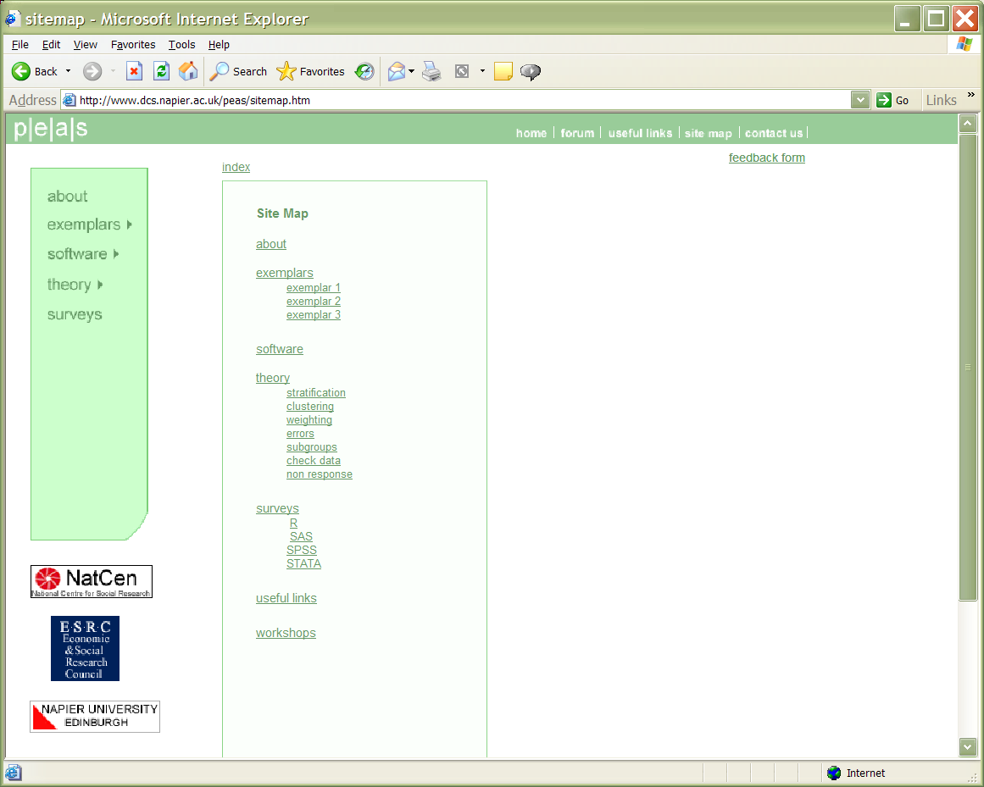

References (to complete & move before appendices?)
Draper, S. W., Brown, M. I., Henderson, F. P., & McAteer, E. (1996). Integrative Evaluation: An Emerging Role for Classroom Studies of CAL. Computers and Education, 26 (1-3), 17-32.

Gunn, C., & Brussino, G. (1997). An Evolutionary Approach to CAL. Active Learning, 6.

Lazar, J. (2001) User-centred web development. Jones and Barlett: Sudbury, MA

Levi and Conrad 1996 Interactions

Molich, R., and Nielsen, J. (1990). Improving a human-computer dialogue, Communications of the ACM 33, 3 (March), 338-348.

Monk, A., Wright, P., Haber, J. and Davenport, L. (1993). Prentice Hall: Hemel Hempstead

Nielsen, J. (no date) How to Conduct a Heuristic Evaluation online at: http://www.useit.com/papers/heuristic/heuristic_evaluation.html {accessed 25 November 2004}

Nielsen, J., and Molich, R. (1990). Heuristic evaluation of user interfaces, Proc. ACM CHI'90 Conf. (Seattle, WA, 1-5 April), 249-256.

Preece, 2000

A full list of participating organisations by sector and location is provided in Appendix 1.
No data available for workshop 2.

